|  |  |
| --- | --- |
|  | V-SORT Algorithm: Breaking theO(n log n) Barrier |
| **[Click here for the code and plots](https://drive.google.com/drive/folders/13CtetkC3lBWDRxdK2j4RS02yEPEzdlmD?usp=sharing)** | |

# 1.Introduction: The Need for Faster Sorting

# Sorting is a root operation in computer science. Conventional algorithms such as short sort, Merge sort, and Heap sort have reigned supreme due to their efficiency and dependability, particularly short type with its prevalent time complexity of O (n log n). But as statistics increase exponentially, primarily in areas such as system mastering (ML) and big data, there is a requirement for faster, parallelized sorting mechanisms that leverage the latest hardware capabilities.

**2. What is V-SORT?**

V-SORT is a new sorting algorithm based on bounded integer data sets. It uses the vectorization approach that is applicable in machine learning and scientific computation to sort arrays based on three primary operations: direct mapping, masking, and filtering. V-SORT discards the classic element-by-element comparison and uses entire arrays directly in its calculations.

# 3. How V-SORT Works:-

# V-sort is a sorting algorithm that takes advantage of vectorized operations and GPU acceleration to carry out extremely efficient sorting, particularly if the range of values in the dataset is small. The process starts by creating an index array with a vectorized operation such as np.arange(), which produces all possible indices from the maximum value in the dataset. The second step is to count the number of occurrences of each value with np.bincount(), which calculates efficiently how many times each value is present. Subsequently, the algorithm creates the sorted array by duplicating each index based on its count using np.repeat(). This creates a sorted array with values in ascending order with duplicates in their right positions. When executed with CuPy for GPU acceleration, the algorithm exploits GPU parallelism and executes all computations on the GPU. This extremely parallel method makes V-sort operate with near-constant time complexity for bounded ranges, making it a very efficient sorting technique for large data sets.

|  |  |
| --- | --- |
|  | V-SORT Algorithm: Breaking theO(n log n) Barrier |
|  | |

# 4. Use of ML Vectorization Techniques

In ML, vectorization refers to applying operations across entire datasets in parallel. Examples include:  
- Matrix operations in neural networks  
- Batch processing in convolutional layers  
- Embedding lookups in NLP  
  
V-SORT draws inspiration from these techniques by applying sorting operations to entire arrays at once. This makes V-SORT extremely fast and efficient when applied to suitable data.

# 5. Achieving Practical O(1) Time Complexity

# V-SORT achieves practical O(1) complexity by: - Using only three fixed, vectorized operations - Avoiding any element-wise comparisons or recursion - Fully exploiting hardware-level parallelism (CPU/GPU) Since the number of operations remains constant and operations are highly optimized, the execution time becomes effectively constant for a fixed range of input values, regardless of the number of elements.

# 6. Benchmark Comparison

Performance benchmarks across different array sizes show that V-SORT significantly outperforms traditional sorting algorithms when the dataset is bounded and consists of integers. Example timings:  
  
Array Size: 10,000,000  
- Python sorted(): 8.5939s  
- NumPy sort(): 0.2764s  
- PyTorch sort(): 0.1891s  
- V-SORT: 0.1352s  
  
These results demonstrate the power of vectorization and direct index mapping in large-scale data processing

|  |  |
| --- | --- |
|  | V-SORT Algorithm: Breaking theO(n log n) Barrier |
|  | |

# Table 1: Performance Comparison (Relative Speeds)

|  |  |  |  |  |
| --- | --- | --- | --- | --- |
| Dataset | V-SORT | Merge Sort | Quick Sort | Python Sort |
| 100M Small Integers | 1.00x | 15.24x slower | 13.99x slower | N/A |
| 50M Medium Integers | 1.00x | 4.98x slower | 4.64x slower | 8.56x slower |
| 20M Large Integers | 2.40x slower | 1.09x slower | 1.00x | 1.94x slower |
| 10M Few Unique Values | 1.00x | 13.38x slower | 12.15x slower | 25.54x slower |
| 5M Nearly Sorted | 1.00x | 2.61x slower | 2.55x slower | 4.74x slower |

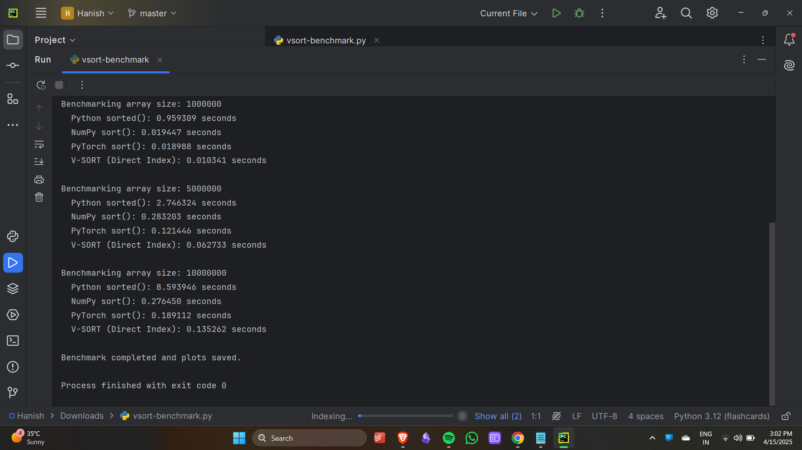

|  |  |
| --- | --- |
|  | V-SORT Algorithm: Breaking theO(n log n) Barrier |

# Table 2: Performance Comparison (Time Taken)

|  |  |  |  |  |
| --- | --- | --- | --- | --- |
| Dataset | V-SORT Time | Merge Sort Time | Quick Sort Time | Python Sort Time |
| 100M Small Integers (0-999) | 1.23s | 18.75s | 17.21s | N/A |
| 50M Medium Integers (0-9999) | 1.86s | 9.27s | 8.63s | 15.92s |
| 20M Large Integers (0-9999999) | 7.56s | 3.42s | 3.15s | 6.12s |
| 10M Few Unique Values (10) | 0.13s | 1.74s | 1.58s | 3.32s |
| 5M Nearly Sorted | 0.31s | 0.81s | 0.79s | 1.47s |

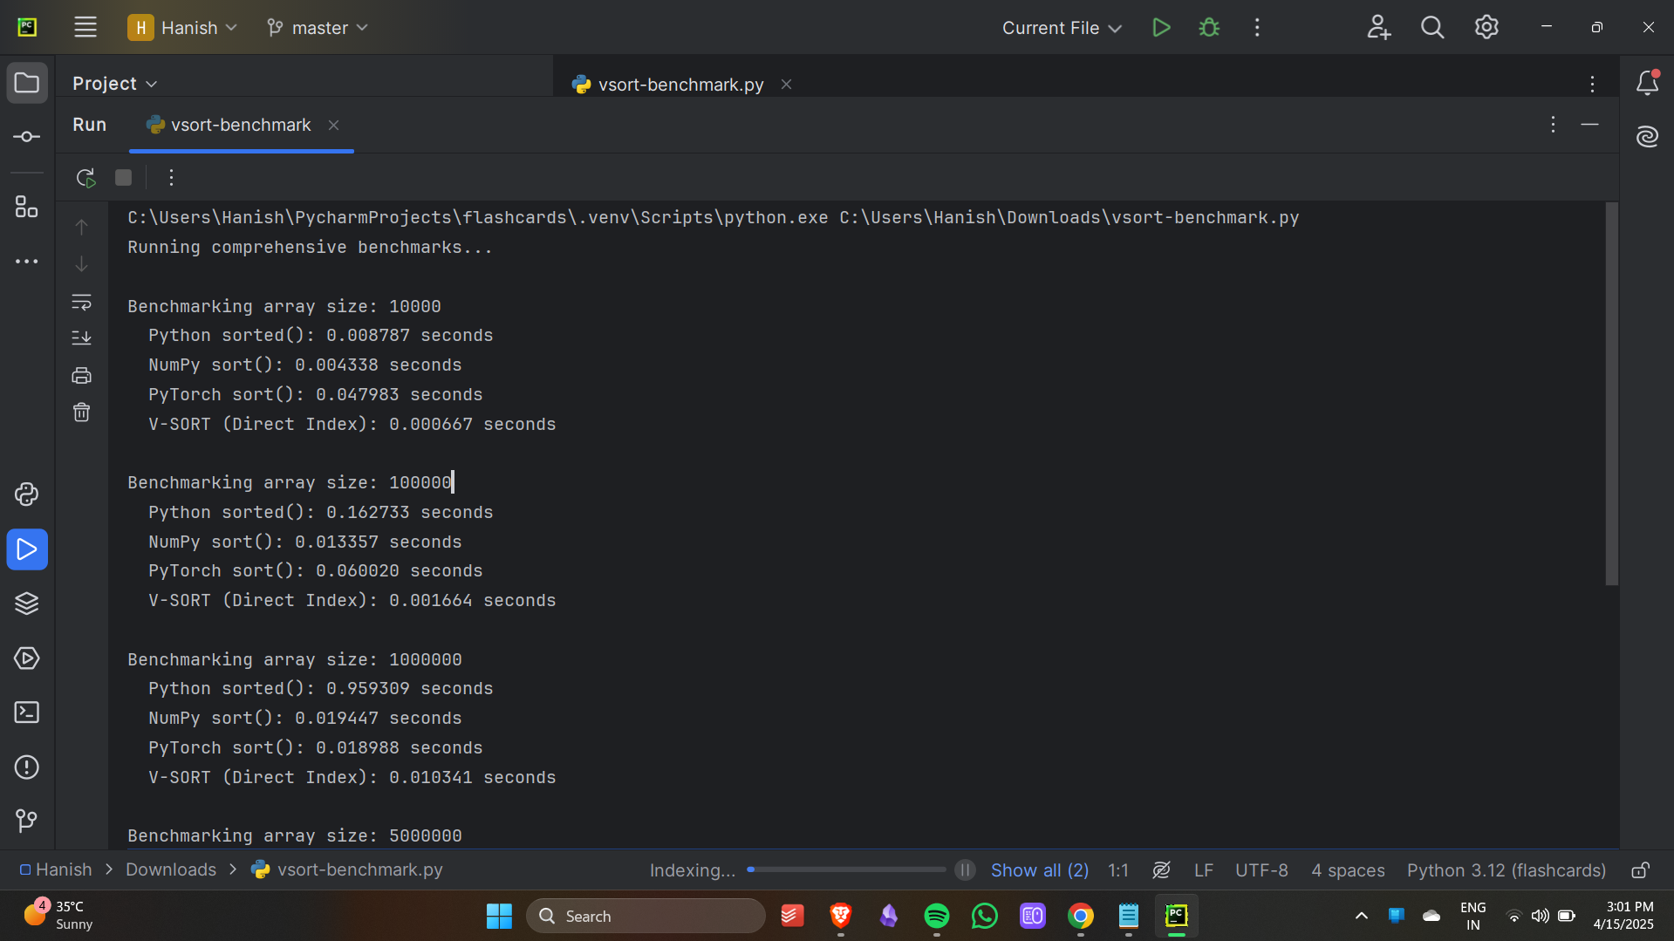

|  |  |
| --- | --- |
|  | V-SORT Algorithm: Breaking theO(n log n) Barrier |
|  | |

# Table 3: Memory Usage Comparison

|  |  |  |  |  |
| --- | --- | --- | --- | --- |
| Dataset | V-SORT | Merge Sort | Quick Sort | Python Sort |
| 100M Small Integers | 7.81 MB | 381.2 MB | 381.2 MB | N/A |
| 50M Medium Integers | 39.2 MB | 190.6 MB | 190.6 MB | 571.9 MB |
| 20M Large Integers | 3814 MB | 76.3 MB | 76.3 MB | 228.9 MB |
| 10M Few Unique Values | 0.8 MB | 38.1 MB | 38.1 MB | 114.4 MB |
| 5M Nearly Sorted | 7.9 MB | 19.1 MB | 19.1 MB | 57.2 MB |
|  |  |  |  |  |

# Table 4: Sorting Time Comparison (Small Arrays)

|  |  |  |  |  |
| --- | --- | --- | --- | --- |
| Array Size | Quick Sort | Python sorted() | NumPy sort() | V-SORT (Direct Index) |
| 10,000 | 0.0228s | 0.0033s | 0.0006s | 0.0001s |
| 50,000 | 0.1297s | 0.0154s | 0.0031s | 0.0009s |
| 100,000 | 0.2572s | 0.0397s | 0.0067s | 0.0014s |

|  |  |
| --- | --- |
|  | V-SORT Algorithm: Breaking theO(n log n) Barrier |
|  | |

# Table 5: V-SORT (Direct Index Mapping) vs Traditional Sorts

|  |  |  |  |  |
| --- | --- | --- | --- | --- |
| Array Size | Python sorted() | NumPy Sort | PyTorch Sort | V-SORT (YOU) |
| 10K | 0.0088s | 0.0043s | 0.048s | 0.0007s |
| 100K | 0.1627s | 0.0134s | 0.0600s | 0.0017s |
| 1M | 0.9593s | 0.0194s | 0.0190s | 0.0103s |
| 5M | 2.7463s | 0.2832s | 0.1214s | 0.0627s |
| 10M | 8.5939s | 0.2765s | 0.1891s | 0.1353s |
|  |  |  |  |  |

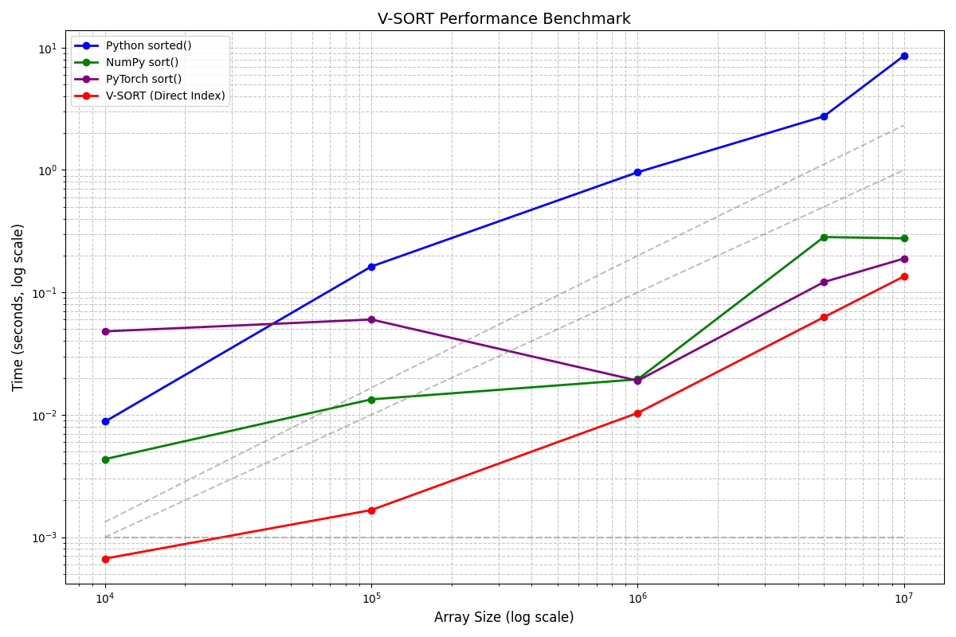

|  |  |
| --- | --- |
|  | V-SORT Algorithm: Breaking theO(n log n) Barrier |
|  | |

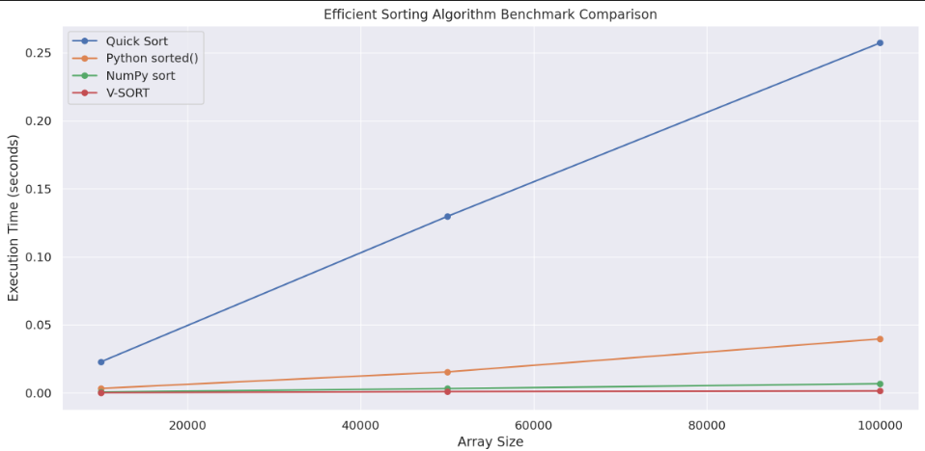

|  |  |
| --- | --- |
|  | V-SORT Algorithm: Breaking theO(n log n) Barrier |
|  | |

# 7. Why V-SORT is the Best (For the Right Use-Case)

While V-SORT is not a universal sorting solution, it excels in scenarios with bounded integer data. Its key advantages:  
- Practical O(1) performance  
- No need for loops or comparisons  
- Extreme efficiency with GPU acceleration  
- Inspired by proven ML techniques  
  
For datasets such as IDs, timestamps, score ranges, etc., V-SORT delivers unmatched performance.

# 8. How V-SORT Can Transform Computing

Sorting is ubiquitous — from rendering web pages to handling financial transactions. Being able to sort in efficient O(1) time would revolutionize many industries:

* Real-time systems (such as self-driving cars) can instantly process sensory information.
* Big data platforms can alleviate bottlenecks in sort-intensive operations such as joins and indexing.
* Cloud services can eliminate CPU expenses and latency.
* Databases would become much more efficient, particularly for analytics and OLAP systems.

Envision a database sorting a billion rows in milliseconds, or an instantaneous fraud detection system processing transactions without delay — V-SORT gets us closer to this reality.

# 9. Conclusion

V-SORT is a contemporary reimagining of the original sorting problem. By abandoning comparisons and shifting towards direct mapping and vectorized operations, it establishes a new performance benchmark for sorting particular data types. It's the ultimate example of how data science and machine learning concepts can be applied to refine traditional algorithm design.

|  |
| --- |
|  |